

# Claim Status Tool

Version 4.0  
Launch: July 30, 2025

## Revision History

| **Date** | **Version** | **Description** | **Author** |
| --- | --- | --- | --- |
| 2020 | 1 | Product Guide | Unknown |
| 3/25/2024 | 2 | Product Guide (Tool Modernization) | Jacob Worrell |
| 6/21/2024 | 2.1 | Expanded Claim Phases (Section 4.5) | Jacob Worrell |
| 6/30/2025 | 3.0 | Changes to Pension Claims; screenshot updates to ensure currency with other VA.gov changes | Saliha Ghaffar |
| 12/19/2025 | 4.0 | Document Status (Section 4.6); updates to Recent Activity and upload failure guidance | Kirk Crawford |

Table of Contents

Claim Status Tool 1

Revision History 2

Table of Contents 3

1. Overview 4

2. User Access 4

3. Navigation 4

3.1 To application from the homepage 4

3.2 Using main menu navigation 5

3.3 Using My VA Dashboard 7

3.4 Authentication from the Claim Status Tool landing page 7

4. Functionality 8

4.1 Viewing list of all claims 8

4.2 Viewing and responding to claim requests 9

4.3 Viewing “Recent Activity” and responding to third-party requests 10

4.4 Uploading files not related to specific requests 11

4.5 Viewing the Overview tab 12

4.5.1 Disability Compensation and Pension Claims (not including Supplemental Claims) 13

4.5.2 Other type of claims 14

4.6 Viewing Document Status 15

4.6.1 File submissions in Progress 16

4.6.2 Files received 17

4.6.3 Files we couldn’t receive (error page) 18

5. Major Issues and Error Messages 19

5.1 File(s) fails to upload when the user attempts to submit evidence 19

5.2 Application fails to load or times out 20

# 1. Overview

The Claim Status Tool (CST) on VA.gov enables users to check the status of a VA claim, decision review, or appeal for these types of benefits:

* Disability compensation (including claims based on special needs like an automobile or clothing allowance)
* Veteran’s or Survivor’s Pension benefits
* Special monthly compensation (such as Aid and Attendance)
* Dependency and Indemnity Compensation (DIC)
* Burial allowance to help pay for a Veteran’s burial and funeral expenses
* Specially Adapted Housing (SAH) or Special Housing Adaptation (SHA) grant

In addition, claimants can use the CST for:

* Requests to add or remove dependents
* Requests for approval of school attendance for dependent children

Additionally, for many of these claims, the CST allows claimants to upload supporting documents online and check if VA has received those files.

# 2. User Access

Users must be signed in to the site and eligible for VA benefits.

## 3. Navigation

Direct URL: <https://va.gov/track-claims/your-claims>

## 3.1 To application from the homepage

To check the status of claims: Users starting from the homepage can use the link in “Top pages” to “Check your claim, decision review, or appeal status.”

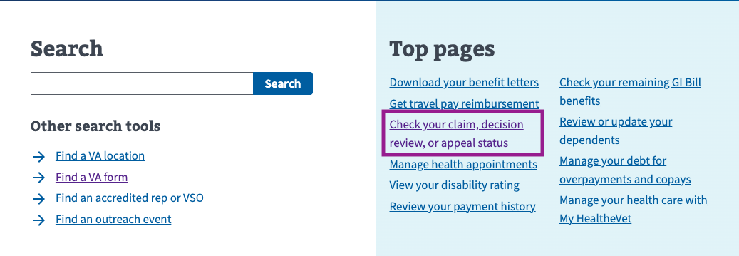

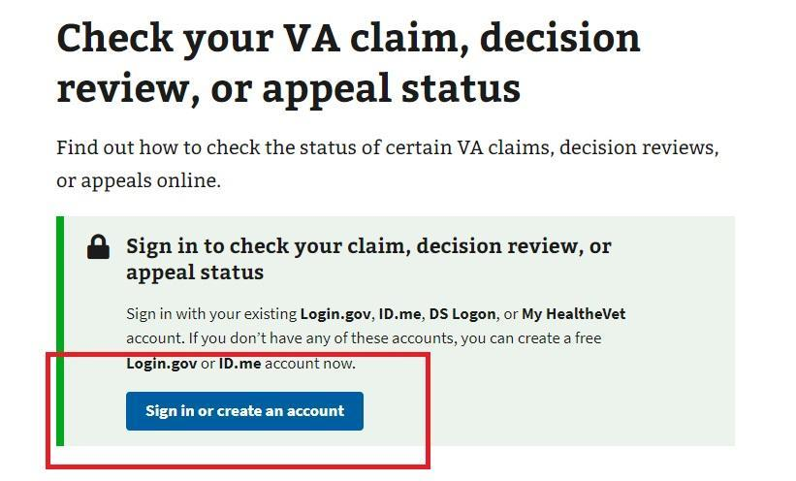

## 3.2 Using main menu navigation

For Disability Claims: Alternatively, users can navigate to the top menu and select VA Benefits and Healthcare > Disability > “Check your claim, decision review, or appeal status.”

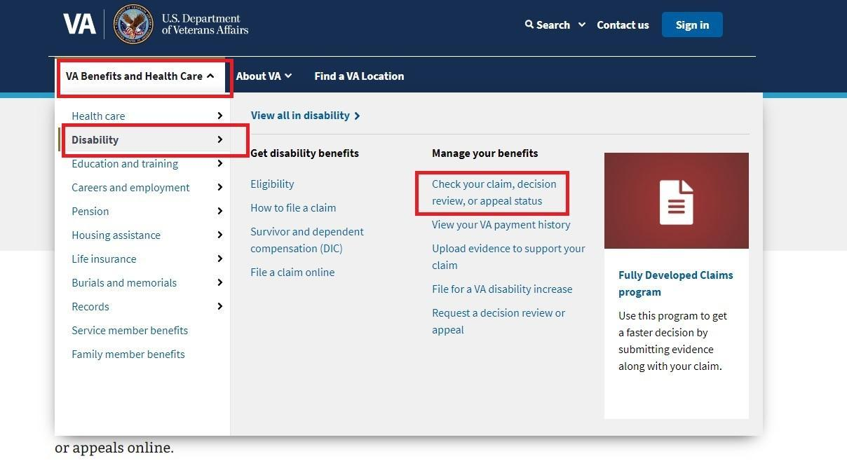

For Pension Claims: Alternatively, users can navigate to the top menu and select VA Benefits and Healthcare > Pension > “Check your claim, decision review, or appeal status.”

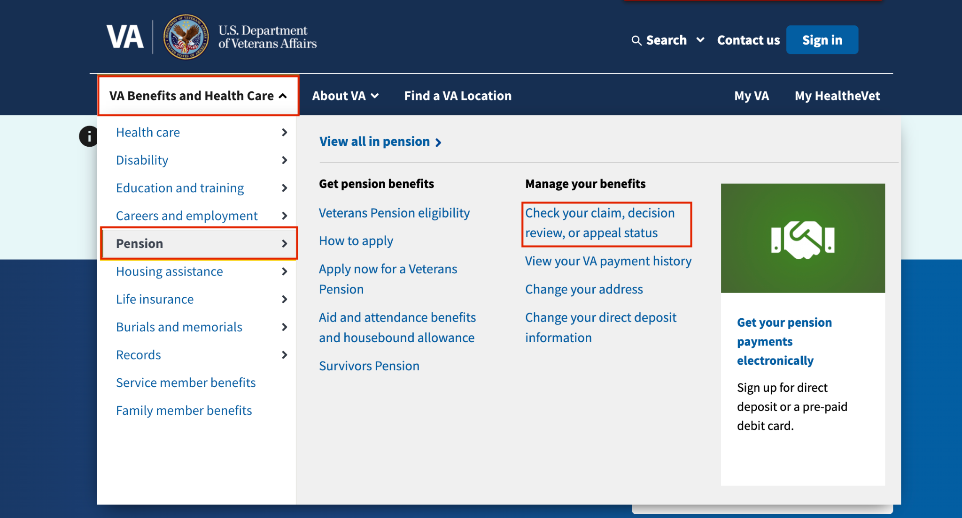

## 3.3 Using My VA Dashboard

Users who sign in from the home page go to [VA.gov/my-va/.](https://www.va.gov/?next=%2Fmy-va%2F) The top of My VA will display a claim with recent activity, if applicable, along with a link to “Review details” (screen readers may announce a more descriptive label).   
  
To access the CST landing page, users can click the “Manage all claims and appeals” link.

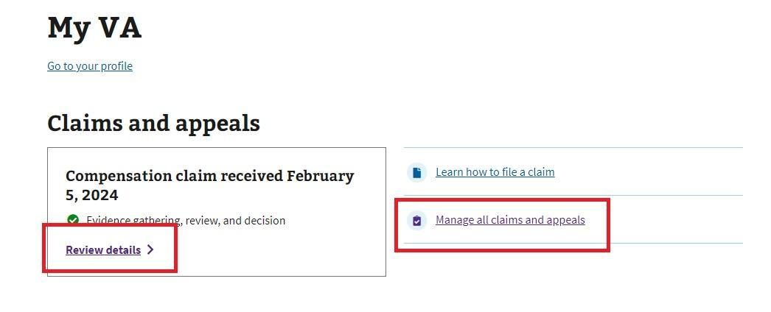

## 3.4 Authentication from the Claim Status Tool landing page

If a non-verified user (LOA1) attempts to access the CST, a message prompts them to sign in or create an account. If they sign in as a verified user (LOA3), CST will look for their claims.

A screen shot of an alert with following content:  

Heading above the alert: Check your VA claim, decision, or appeal status. 

Text under the heading: Find out how to check the status of certain VA claims, decision reviews, or appeals online. 

Alert heading: Sign in with a verified account.

Alert content: 

You'll need to sign in with an identity-verified account through one of our account providers. Identity verification helps us portect all Veterans' information and prevent scammers from stealing your benefits. 

Don't have a verified account? Create a login.gov account. We'll help you verify your identity for your account. 

Not sure if your verified? Sign in here. If you still need to verify your identity, we'll help you do that now.

Alert button: Sign in or create an account

Alert link: Learn about creating an account

# 4. Functionality

## 4.1 Viewing list of all claims

From the first screen of CST, the user will be able to see a list of their claims. The claim “cards” on this page are displayed so that claims with new evidence requests appear at the top of the stack. Otherwise, claims and appeals are sorted in reverse chronological order. Additionally, open claims are listed above closed claims.  
  
Claim cards show the following info:

* Type of claim
* Whether the claim is “in progress” or “closed”
* When the claim was received
* Which step the claim is in (for compensation claims)
* The last update date for the claim
* Whether an item requires attention.

Some claim cards may also display an alert if VA couldn’t receive one or more files the user submitted online; selecting this alert takes the user to the “Files we couldn’t receive page” for more details and next steps.  
  
For the most common claim type, “Disability compensation,” the next step is usually to click on the link, “View details,” to review items that need attention.

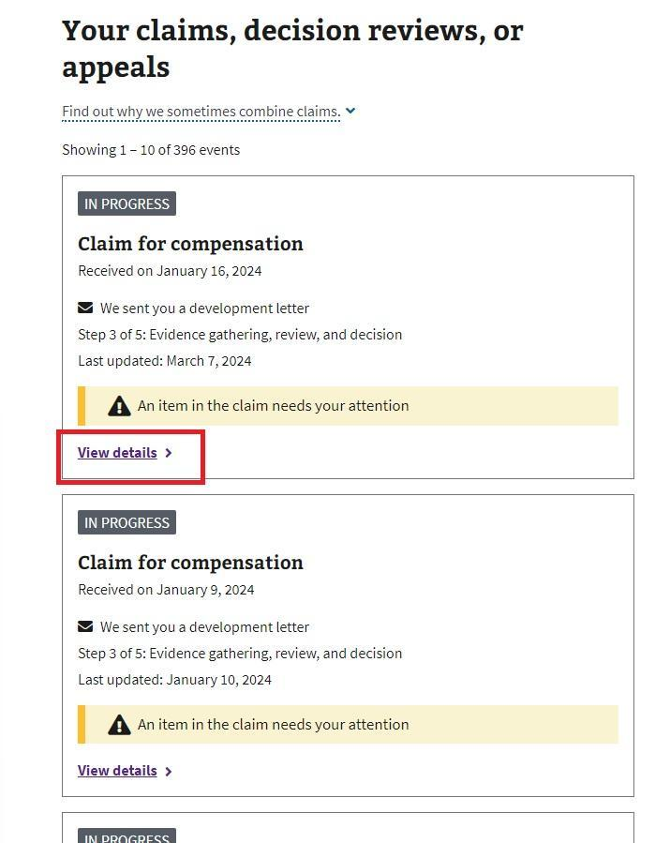

## 4.2 Viewing status and responding to claim requests

In the claim details page, users can view the date the claim was received, their claimed conditions, and the latest information on their claim.

Information in the Status tab is divided into two main categories: “What you need to do” and “What we’re doing.” The former includes specific alerts and evidence requests that require the user's attention, while the latter outlines the actions being taken by the VA.

Content in the “What you need to do” section takes the form of individual alerts, often in the form of specific evidence requests. To view more details about a specific evidence request, the user clicks the link, “View Details.”

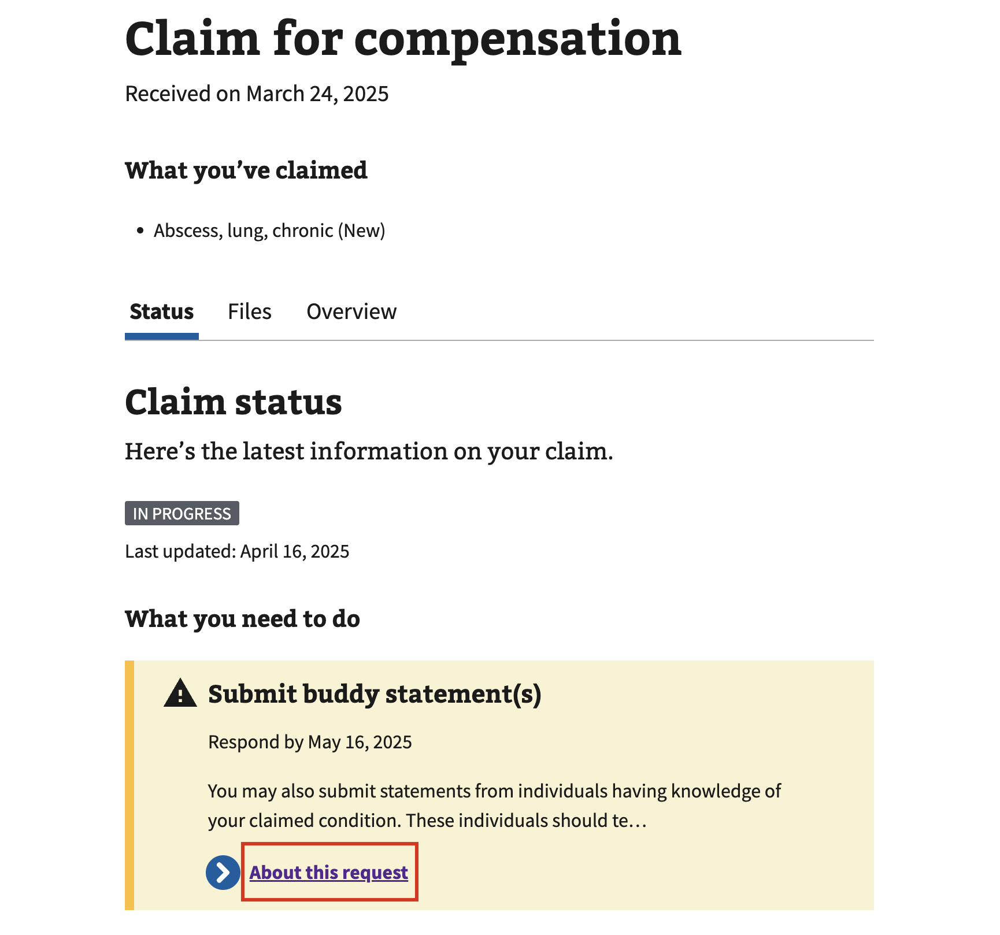

Once the user clicks “View details,” they are presented with a detail page for the request that provides a more detailed description. Additionally, if the request is for a document, users will have the ability to upload the specific document requested by clicking the button, “Upload file,” and selecting a file from their device.

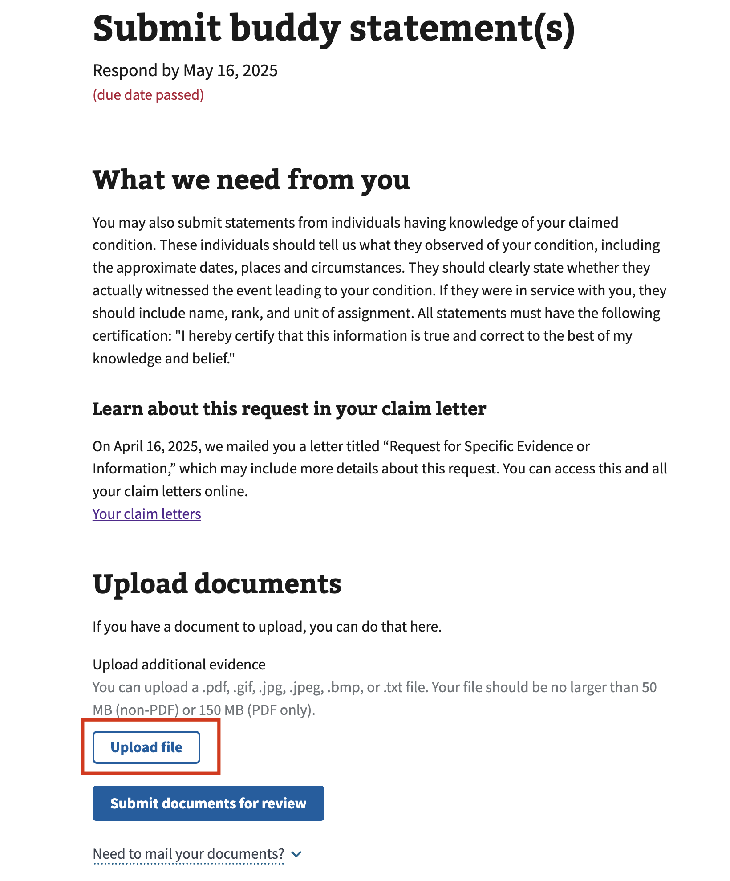

The user can select a file from their device. Once the file is uploaded, they’ll select the file type that most accurately matches the document they uploaded from the drop-down.

After the user uploads their file, they can click the button, “Submit documents for review,” to complete the file submission. After submission, these files follow the same document status behavior described in Section 4.6 and may appear in “Recent activity” and on the “Files” tab.

## 4.3 Viewing “Recent Activity” and responding to third-party requests

On the “Status” tab, if a user scrolls down the page to the “What we’re doing” section, they will see a list of “Recent Activity.” This activity log displays major claim actions taken, including the time the action was taken and a brief description of each action. This can include document-related updates, such as when VA opens an evidence request or receives documents the user submitted online. If there’s an open third-party request, users will see an alert for it. While they aren’t responsible for completing this request, they can provide the requested information if they have it by clicking on the link, “Add it here,” within the alert.

A screenshot of the What we're doing section of the Status tab. The section has a card that explains the Veteran what step their claim is in. The card links to an overview of the process page. 

The section also contains a recent activity section that lists the recent actions that have been taken on the claim. Each action has a date and a description. The types of actions shown in the screenshot include a confirmation that a document was received and a third party request alert. This alert is highlighted in the screenshot. 

The user will then be navigated to a request detail page, as described in Section 4.2. The instructions for uploading documents are similar, but they indicate that the request has been made to someone outside VA, and that the user has the option to upload the document if they have it and would like to.

## 4.4 Uploading files not related to specific requests

At any time, while a claim is under review by VA, a claimant can upload additional evidence that supports that claim. To do this, they can click the “Files” tab from any claim detail page.

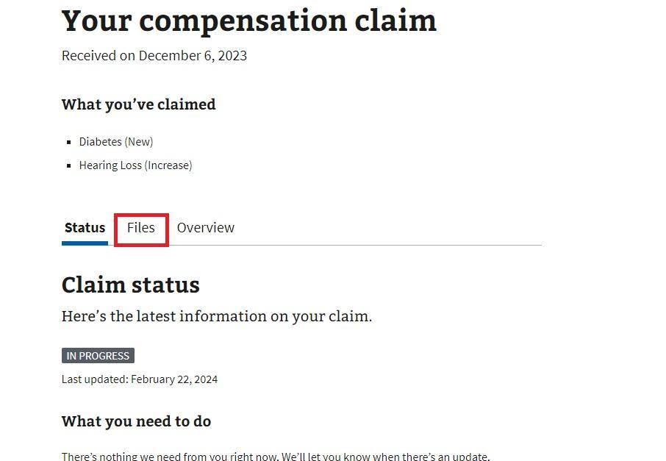

## 4.5 Viewing the Overview tab

A user can click the “Overview” tab to learn about the claim process. Information under this tab describes the phases of the claim process so claimants know which phase they’re in and where it sits in the overall process.

Another way to see this timeline is from the “Status” tab in the “What we’re doing section.” There, they will see a condensed description of the current phase of their claim, along with a link labeled “Overview of the process.” Clicking this link will also direct them to the “Overview” tab.

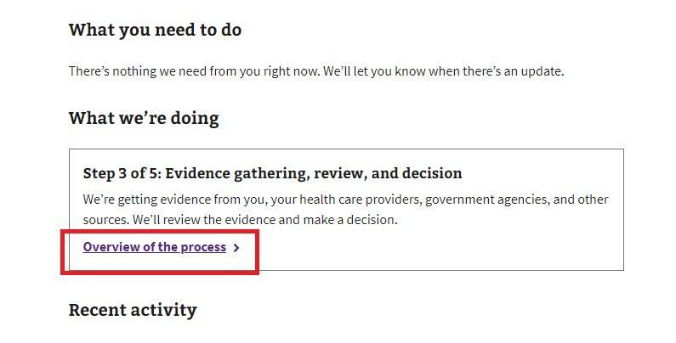

### 4.5.1 Disability Compensation and Pension Claims (not including Supplemental Claims)

For initial disability compensation claims, the user will see an eight-phase process graphic and an accordion item for each of the eight phases of the claims journey. Expanding the accordion reveals a description of that step. One accordion item corresponding to the phase the claimant is currently in will automatically expand. Icons distinguish between steps that are complete, the current step, and steps that are still in progress.

A screenshot of the Overview tab for a specific claim. The content on this tab provides the Veteran with a graphic showing the 8 step claim process and an expandable section for each step. 

The claim process graphic shows the 8 steps of the claim in a line. Each step is indicated with a number in a circle. There are cyclical arrows from steps 3 and 6 indicating this process could repeat multiple times from steps 3 through 6. 

The screenshot shows the "Step 3: Evidence gathering" section expanded. This section has a flag icon to indicate that this specific claim is currently on this step. Steps 1 and 2 have green check icons indicating those steps are complete. The future steps have no icon indicator. 

### 4.5.2 Other type of claims

Claims other than Disability and Pension will display a more generic “Overview” condensed into 5 steps. Note: We anticipate providing more in-depth information about other claim types in the future.

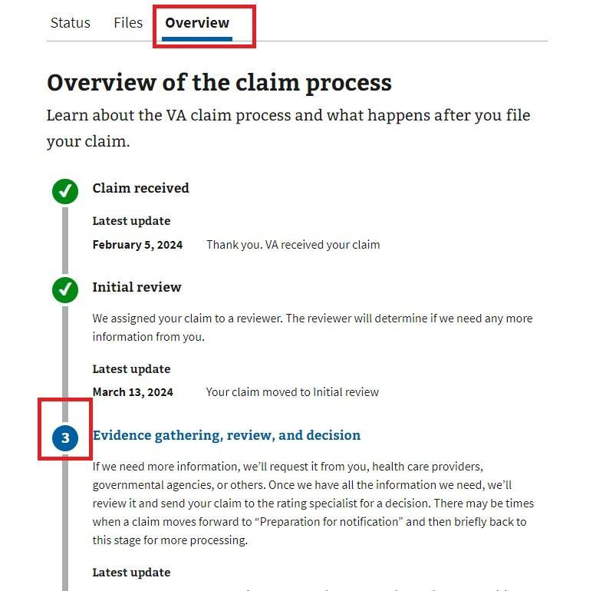

## 4.6 Viewing Document Status

Document status helps claimants understand whether VA has successfully received files they submitted online and what to do if there is a problem. After claimants upload evidence for a claim, either in response to an evidence request or as additional evidence, they can view document status in two places:

* On the “Files” tab for a specific claim, under the headings “File submissions in progress” and “Files received.”
* On the “Files we couldn’t receive” page, which shows files that failed after submission. A link to this page appears on the “Files” tab only if any file submissions have ever failed for the specific claim.

### 4.6.1 File submissions in progress

After a claimant uploads evidence on the “Files” tab and selects “Submit documents for review”, the files may take some time to be received by VA systems. We communicate to claimants that recent submissions may still be in progress, even if they haven't yet appeared in the list of received files.

On the “Files” tab, below the heading “Claim files”, the “File submissions in progress” section:

* Explains that files uploaded after 7:00 p.m. EST will show with the next day’s date
* Explains that documents submitted using this tool may take up to 2 days to be received
* Informs the claimant when there are no submissions currently in progress

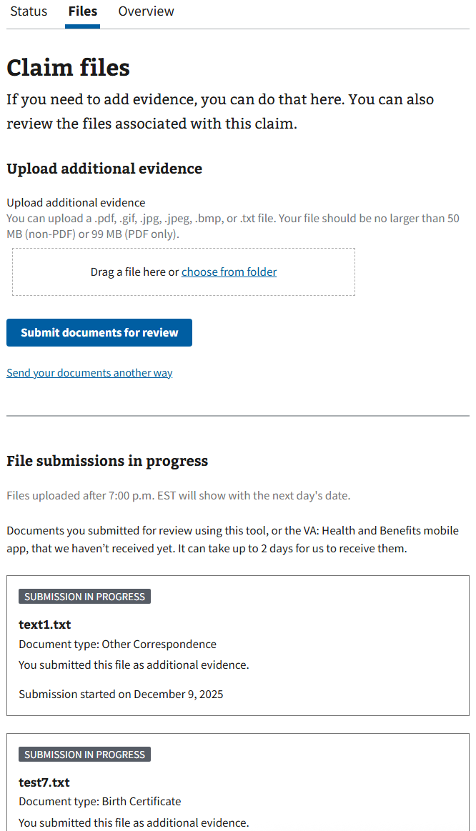

### 4.6.2 Files received

Once VA systems have successfully received a file submitted online, it appears under “Files received” on the “Files” tab.

The “Files received” section:

* States that it lists files received after the claimant submitted them using this tool

Clarifies that files submitted by mail or in person will not appear in this tool, whether they were submitted by the claimant or by others.

For each document, it shows:

* A status tag:
  + “Pending review”
  + “Reviewed by VA”
  + “On File” (for documents provided as additional evidence, i.e. not in response to an evidence request)
* The file name
* The document type selected at upload (e.g. Birth certificate, Copy of DD214)
* A short description, such as indicating that the claimant submitted the file as additional evidence
* The date the file was received

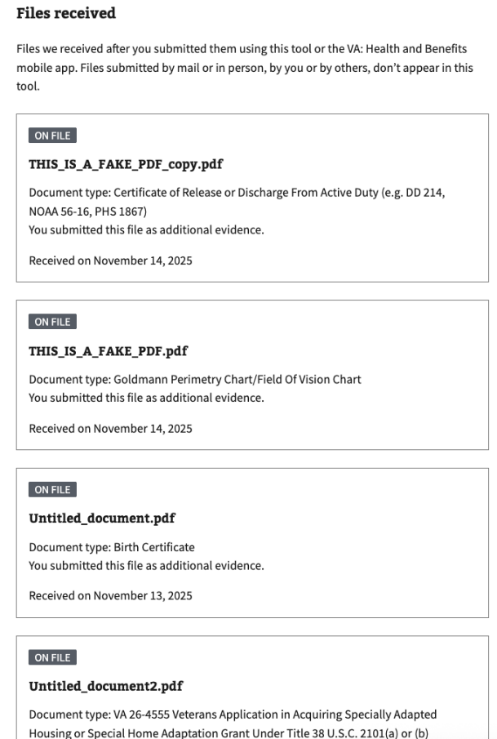

### 4.6.3 Files we couldn’t receive (error page)

Sometimes a file appears to upload successfully, but fails later when being sent to, or processed by, a downstream VA system. In these cases:

* The claimant receives an email that explains that VA couldn’t receive one or more files and provides a link to learn more
* Following that link takes the claimant to the Files we couldn’t receive page in CST

The “Files we couldn’t receive page”:

* Explains that VA couldn’t receive some files submitted online, and lists the names of the files we couldn’t receive

Instructs the claimant to resubmit those documents by mail or in person because we expect the same failure to occur if they try to upload the file again

* Provides mail and in-person options (including the Evidence Intake Center mailing address and a link to find a regional office)
* Explains how to confirm VA has received documents submitted by mail or in person (by calling 800-827-1000)
* Includes contact information for the VA benefits hotline

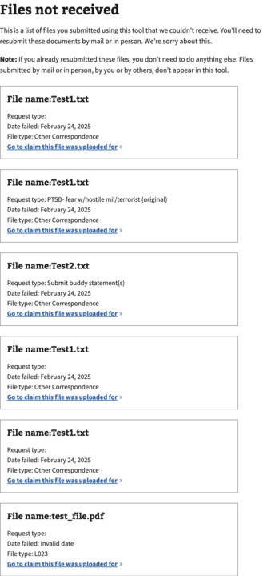

# 5. Major Issues and Error Messages

## 5.1 File(s) fails to upload when the user attempts to submit evidence

If a file fails to upload, the user will be presented with an error alert indicating that an issue has occurred. This alert can occur due to one of the downstream services that provide the information being temporarily unavailable or due to application downtime. When this happens, the user should wait 1-2 hours and then attempt the action again.

In some cases, a user will upload a file, which appears to be successful, but VA.gov will later learn of a failure in delivering the file to another VA system after the user has left the website. When this happens, we send the user an email to notify them of the failure. On this page, the user can see which files couldn’t be received and instructions for resubmitting them. In these cases, we strongly recommend that the user send the document by postal mail to the address provided in the email or bring the document to a regional office, as we expect the same failure to occur again if they upload the file to VA.gov.

## 5.2 Application fails to load or times out

There are also some cases in which the entire application itself fails to load or times out. The user may see an error message stating that the application failed, or the application may simply never display the content. In both cases, the user will likely try to refresh the page in their browser, and sometimes that will resolve the issue. Suppose the application fails to load after repeated attempts to reload. In that case, there may be a service issue affecting all of VA.gov or a service upstream to the application, preventing it from loading. In these cases, the user should wait 1-2 hours before trying again.